Course and Teacher Evaluation Subcommittee
Annual Report
Course and Teacher Evaluation Subcommittee

Ann-Marie Doble, Jamal Love, and Cecilia Yudin

May 2022

Table of Contents

- Motivation and Background
- Methodology
- Findings
- Recommendations
- Recommendation Implementation Timeline
- Considerations for Next Subcommittee
- Appendix

Motivation & Background

The work of the Course / Teacher Evaluation Subcommittee began as a recommendation from the 2020-2021 DEI Curriculum committee for:

“...the incorporation of a “question asking students for feedback regarding DEI issues in the course onto their Mid-Semester Feedback requests” and promote a “Feedback System that enables students to provide feedback (anonymously if desired) to their instructor, to the DEI Office, and/or to their Program Office regarding DEI issues”.

The work was later refined to focus on Course / Teacher Evaluations through the direction of Associate Dean for DEI per the request of Dean Fournier to:

“Add questions to the current C/T Evals on accessing academic freedom, expression, and inclusivity.”

As a result of these two efforts, our subcommittee members’ shared identities as Questrom MBA students, and what we considered accomplishable within the 7-month timeline we felt that our time and energy would be best spent on assessing the current use and awareness of Questrom’s current Course / Teacher Evaluation. We felt it was imperative to first assess students’ knowledge of and responsibility to the current survey, before changes were to be made to a system that was possibly underutilized and misunderstood.

“The Course Evaluation Subcommittee is focused on assessing students’ utilization of Questrom Course Evaluations and awareness of the Questrom Course Evaluation Report website. “

C/T Evaluation Subcommittee Goals FY21-22

- Identify the existing structure and uses of the Course/Teacher Evaluations (C/T Eval) at Questrom.

- Build awareness of the C/T Eval process through an education campaign.

- Develop a plan for formalizing a mid-semester/ongoing feedback.

Methodology
We engaged with two internal Stakeholders to understand some foundational information about the background of course evaluations.

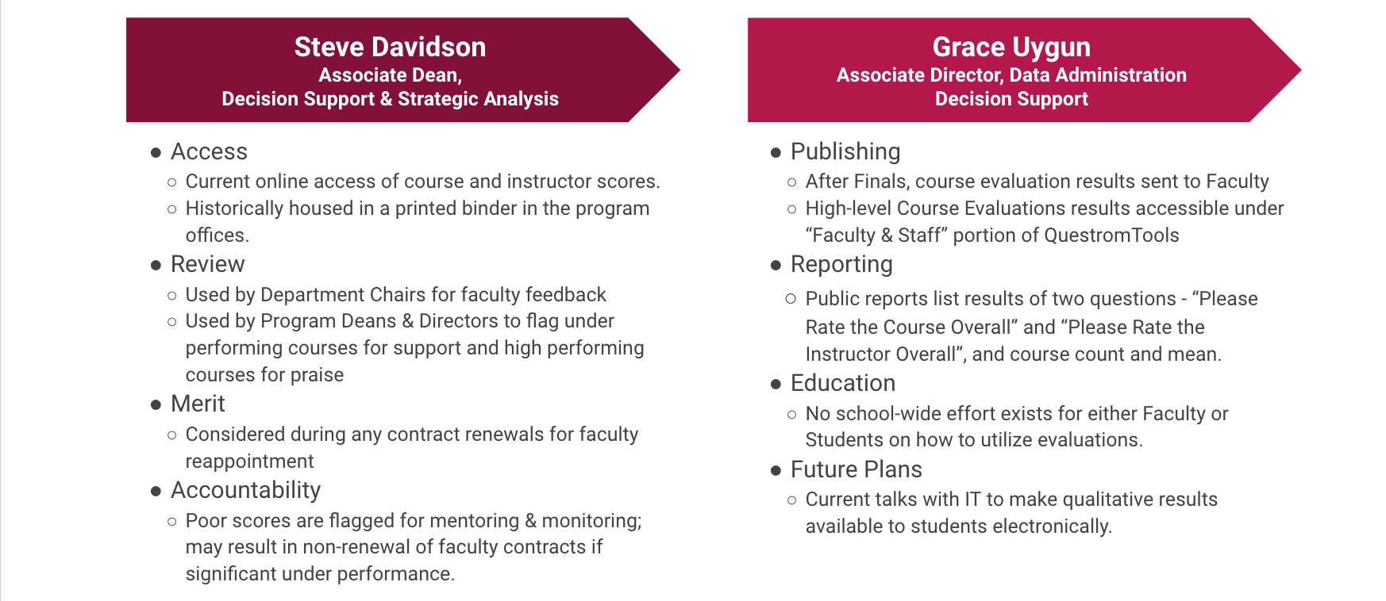

We conducted an online survey and focus groups which were guided by our goals to understand awareness, usability, benefits, and ways to improve Course / Teacher Evaluations.

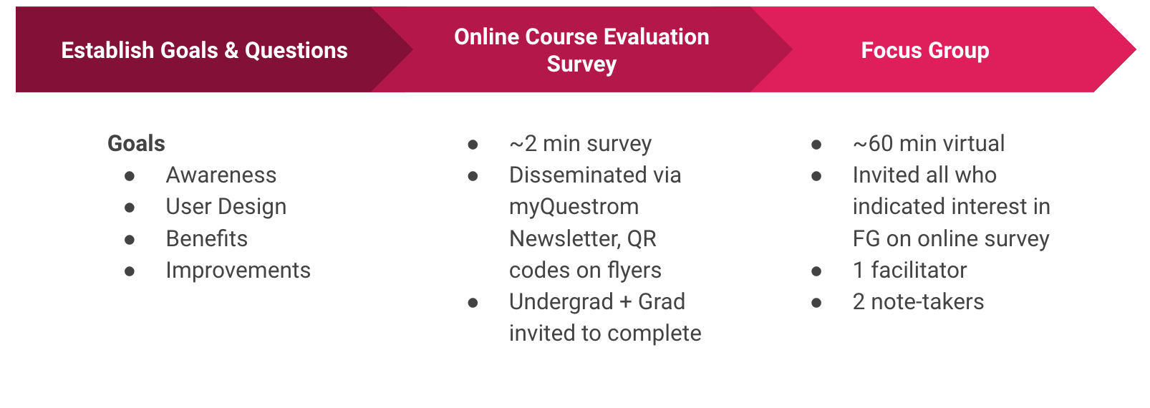

Findings

Listed below is what we uncovered from our survey and focus group efforts
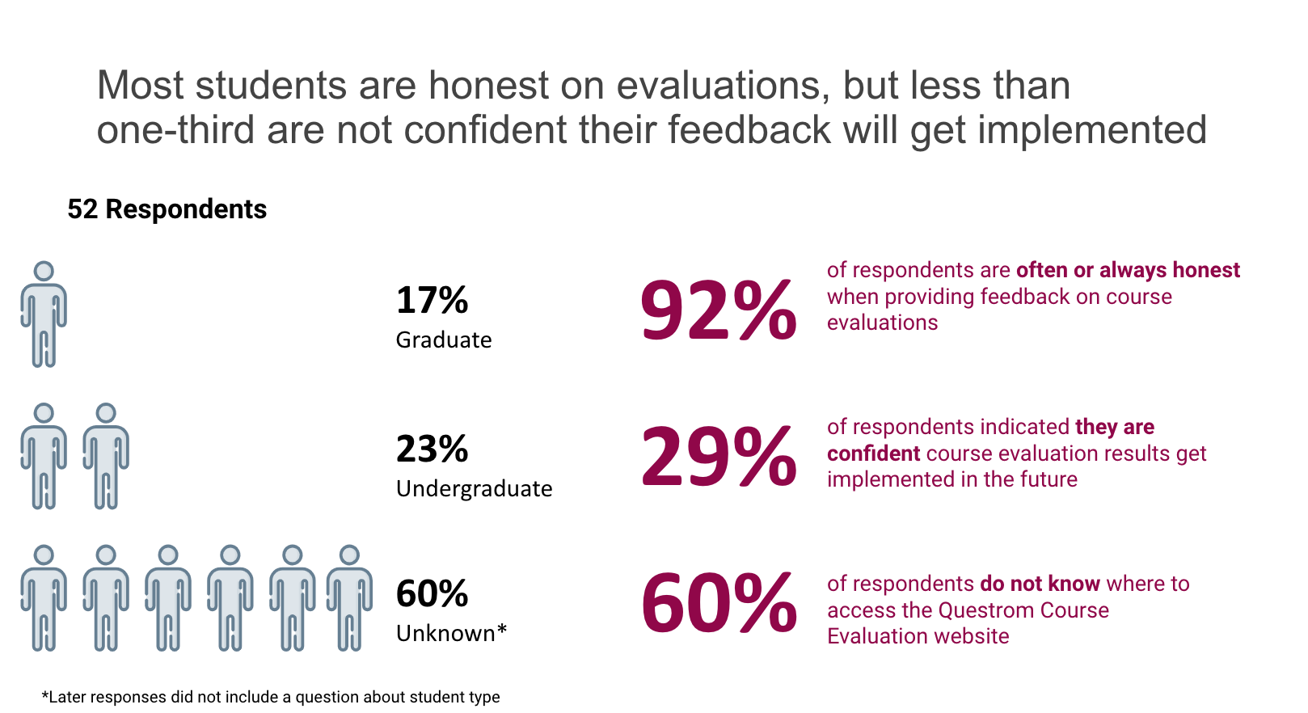

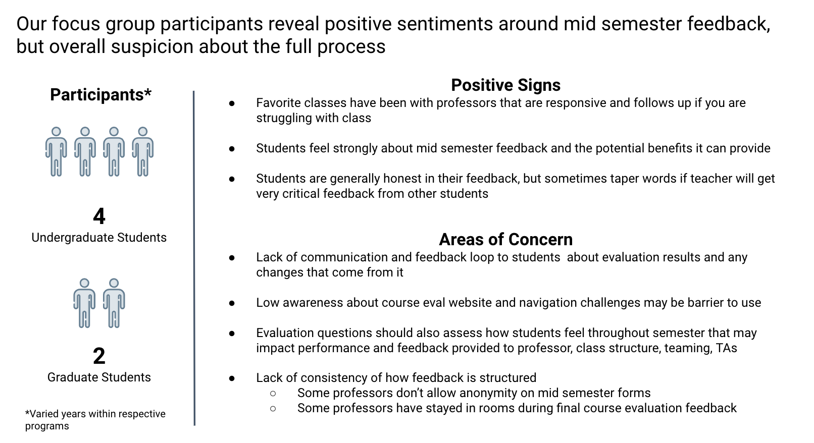

Recommendations

Recommendation #1: Better Promotion Around Course Evaluation Website

We have thought about three distinct times that Questrom can utilize for promotional efforts of the C/T Eval website and mocked up three potential locations where the C/T Eval website can be featured.
When | Why | How
Beginning of Each Semester | - LAUNCH  - Summer Orientation  - New Syllabus Review | - Included in academic presentations  - Noted in Questrom syllabi
Registration Time | - Additional tool for students looking at next semester’s registration and during advising Meetings | - Utilize TV screens within the Questrom building  - Listed with Questrom courses on BU’s Student Link website
End of Semester | - Once evaluations have been updated to share widely and proudly  - Transparency messages to students the importance of accountability | - Send targeted emails to all Questrom students; access to enrolled courses and invitation to review any course evaluation.

Include Course Evaluation Link on StudentLink
Part of the promotion campaign can include a link to the C/T Eval website directly along with the University Class Schedule on the StudentLink so students have increased access when determining their schedules.

Promote Course Evaluations Across Digital Screens
Another part of the promotion campaign can utilize the screens that are located throughout the Hariri building with messaging like this to inform students about the course evaluation link that is currently up and running.
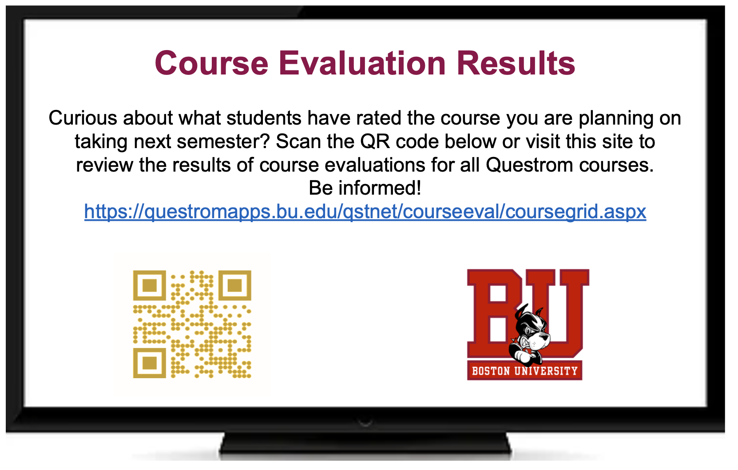

Email Example about Course Evaluations
Another aspect of the promotion campaign can include personalized emails to all students on a periodic cadence to remind them about the existence of the C/T Eval website. All students can automatically be included with the potential option for students to opt out.
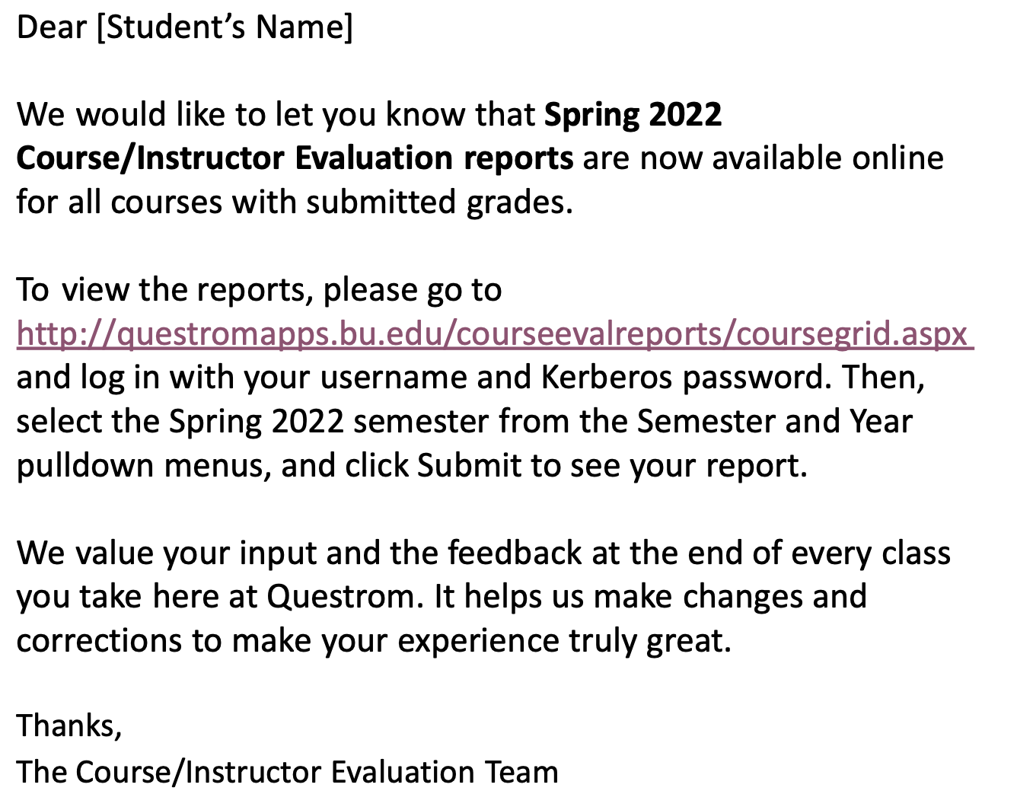

Recommendation #2: Increase Awareness of Course Evaluation Results
We selected three areas of importance regarding the current C/T Eval website that Questrom can take into consideration.

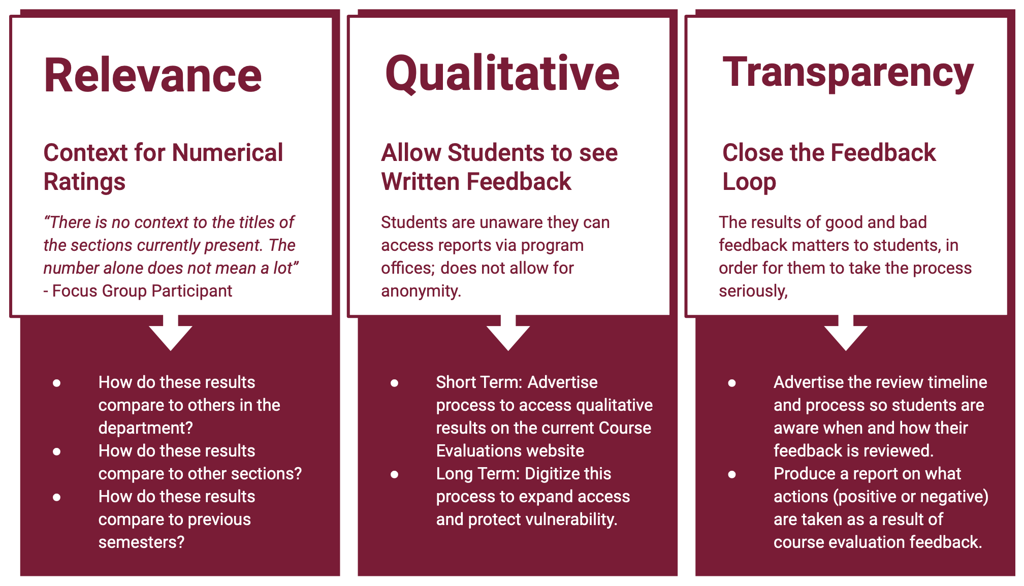

Recommendation #3: Institute mandatory mid-semester feedback for all Questrom courses within specific date range

The mid-semester feedback was a popular aspect of the classroom experience to our focus group participants.

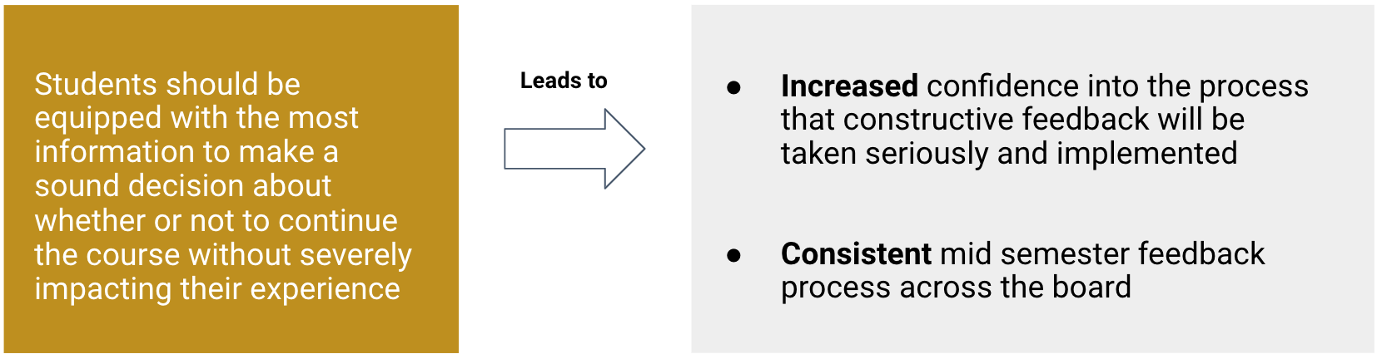

Recommendation #4: Review current evaluation questions for intent and clarity while adding ones that students feel are more pertinent.

We believe that all course evaluation questions can eventually be reviewed, but two particularly stood out to the students from our focus groups. Students also expressed to us a few questions to add to the course evaluations.

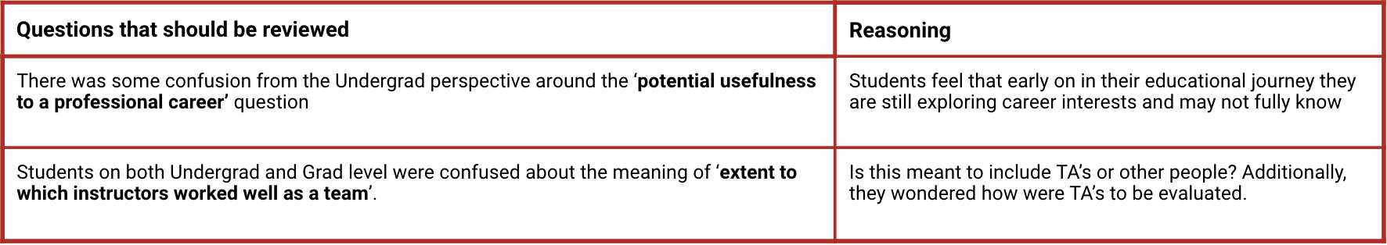

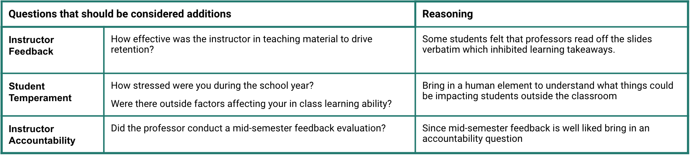

Recommendation Implementation Timeline

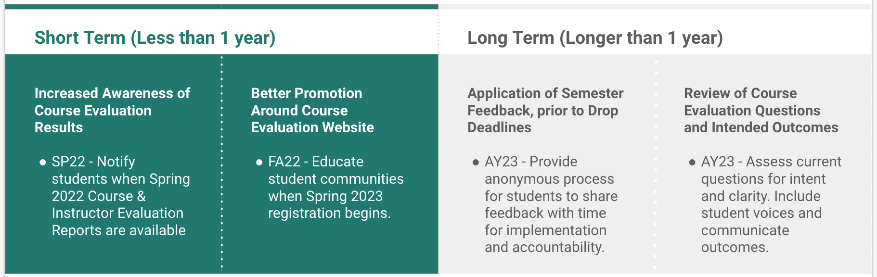

Considerations for Next Subcommittee

- Expand Education & Awareness Campaign

- Focus on Mid-Semester Feedback Offering

- Review of Course Evaluation Questions
  - What are you asking for and why?
    - This could lead to a edits, removals, or additions of particular questions
  - Communicate these changes/updates to students for increased understanding

Appendix

Current List of Words of Concern Flagged on Evaluations
- Racist
- Racial
- Racism
- Misogyny
- Xenophobic
- Bias
- Biased
- Intolerant
- Anti-feminist
- Chauvinist
- Misantrop
- Bigot
- Phob
- Blind
- Sensitive (to pick up forms of insensitive/insensitivity)
- Skin color
- Disrespect
- Diversity
- Diverse
- Uncomfortable

Student Survey Questions
- Do you as a student know where to access Questrom course evaluation results?
- What do you / would you use the results of previous Questrom course evaluations for?
- How confident are you on a scale of 1-5 (1 being not confident, 5 being very confident) that feedback from your course evaluations will get implemented in the future?
- How honest are you in your feedback on the course evaluations?
- Assuming you were enrolled in 4 classes last semester, what percentage of end-of-course evaluation forms did you fill out?
- Do your current Questrom professors implement some type of mid-semester Feedback?
- Assuming you were enrolled in 4 classes last semester, what percentage of your professors initiated a mid semester feedback evaluation?
- Are you a graduate or undergraduate student?

Focus Group Questions
Question Set 1.
Would anyone like to share about a class they have taken?
How did you express your sentiments/feelings about this class after taking it?
- How did you assess whether to take this class before taking it?
- Does anyone else want to share?
Question Set 2
Would anyone like to share what question(s) they found to be the most important during evaluations of a course/professor?
- What specifically about the question made you choose it?
- Follow up questions
- How honest are you when providing feedback on the course evaluations?
- Are there any questions not on the course evals that you would like to see?
- What do you use the course evals for?
- What do you think happens after course evals are collected?
Question Set 3
Would anyone like to share their experience with mid-semester feedback in a class?
- What has mid-semester feedback looked like in your class?
- Follow up questions
- What happened after mid-semester feedback?
- What format of collecting feedback do you prefer? Why?
- What are your thoughts about mid-semester feedback?
Question Set 4
https://questromapps.bu.edu/qstnet/courseeval/coursegrid.aspx
Would anyone like to share what they think it is?
- This is Questrom Course Evaluation website, where they publish the results of the course evaluations. In the chat, I will drop a link to the website. I want you to spend a few minutes browsing the website.
- Follow up questions
- What are your initial thoughts about the website?
- How could this website be changed/updated to be more useful for students?
- What do you think would help spread awareness about this website? Increase traffic?
Question 5
As part of the evaluation process, what would you want to know from your students that could help you make changes/improvements?

Collection of Focus Group Quotes
Awareness of Course Evaluation Website
- “Putting it on Student Link next putting it on the Questrom TVs to advertise the website. What will attract students the most, is having the feedback on the site.”

- “There can be more marketing, especially an email, putting it on StudentLink will allow students to find it.”

- “I’ve never heard of this site before, none of my friends did, I tried to Google it and could’t find it.”

- “I have used this site before, very well hidden within certain Boston University. Instead, I go right to RateMyProfessor.com. The site can be very valuable but it’s difficult to find. Was looking for a course that had bad feedback. QuestromTools is very complicated. I’m six months into my program and still confused on how it works.”
- “Questrom can bring awareness during times when people are registering for classes; or maybe include a link in email ‘If you want to learn more about a class’.”

Using the Course Evaluation Website
- “One pet peeve, the calendar year is automatically set to the current year, so if you don’t remember to adjust, you’ll get no results. I suggest YEAR is changed to ANY like all of the other categories.”

- “Could the department share what happened with a professor who received a bad rating? Feedback loop is broken.”

- “How do we know if our feedback is being taken into consideration?”

- “Found out about it 3 weeks ago. Very well hidden. Never knew it was a collection of reports that was published. Feels like it’s being done on purpose. How to know what is being filtered in/filtered out. Very suspicious of data collected in this way and what is the real intention behind it.”

- “There is no context to the titles of the sections currently present. The number alone does not mean a lot .“

Course Evaluation Survey Flyer
