Making Records Visible/Invisible on your My CV Profile and Questrom Web Profile
Page 1: Information about My CV and Questrom web profiles.
Page 2 & 3: Instructions for making records visible/invisible
Information about My CV and Questrom web profiles:
You can make records visible/invisible on your My CV profile and, in the cases of Publication, Presentation and Awards records, on your Questrom web profile.
- You can access/view your My CV profile by clicking on “Edit my profile” under your name/picture on the My CV home page. The My CV profile can be viewed by all BU users of My CV.
- You can access your Questrom web profile by going to http://www.bu.edu/questrom/faculty-research/faculty-directory/ and finding your name. Again, only Publication, Presentation and Awards records from My CV will appear on your Questrom web profile. Questrom web profiles can be viewed publicly on the Questrom web site.
- Whether a record is visible/invisible does not impact whether it will be pulled onto your Faculty Annual Report and/or Questrom Multiyear Report.
- Records made visible will appear on your My CV profile right away and your Questrom web profile overnight. If you have any questions about your My CV and/or your Questrom web profiles, please e-mail qstfac@bu.edu.

Instructions for Making Records Visible/Invisible:
To make a record visible/invisible, click on the record from the My CV home page (example highlighted in yellow below).
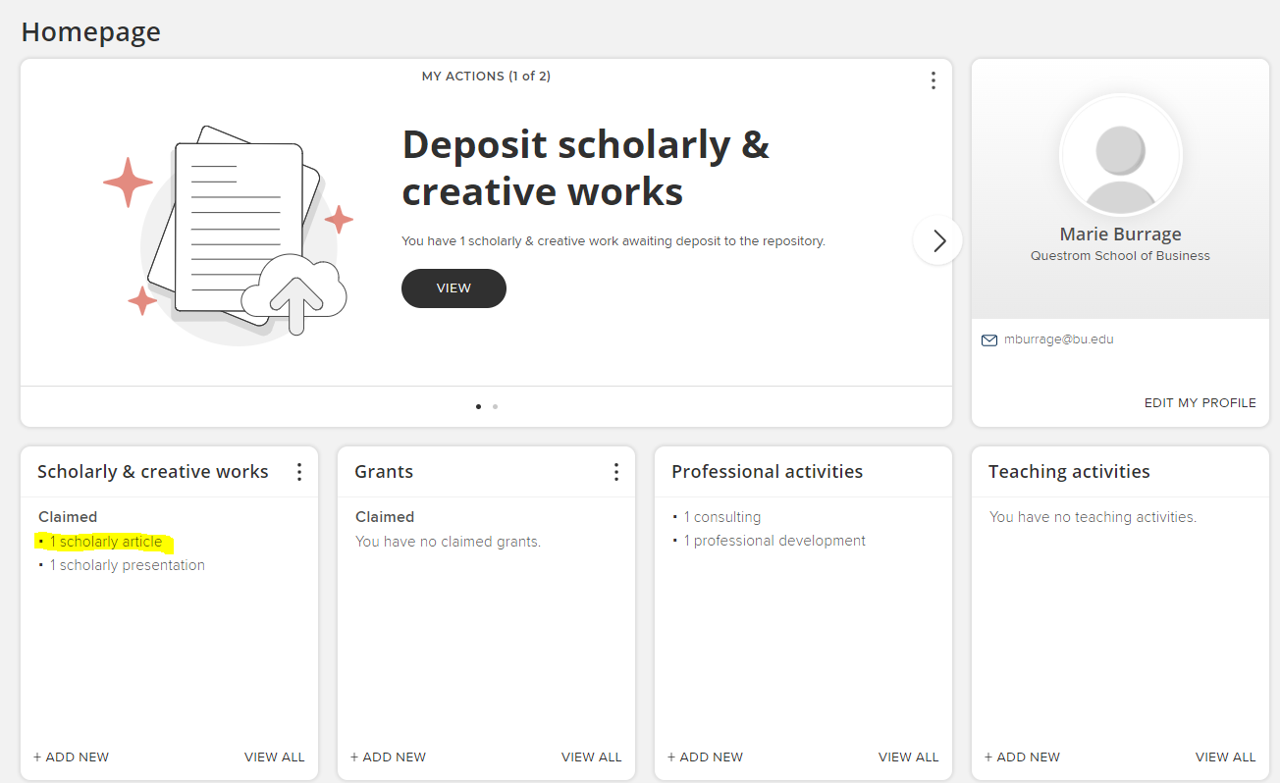
Once in the record, click on the world icon (highlighted in yellow) to display privacy options (see next page):
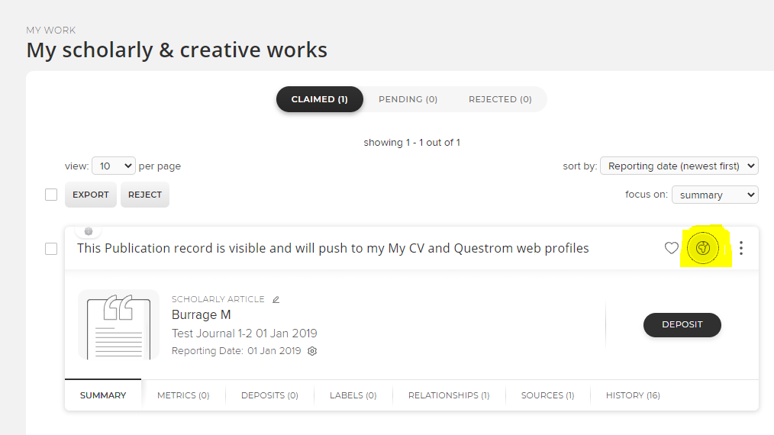
Select “Public” to if you want the record (if it is a publication, presentation or award) to be visible on your Questrom web profile and My CV profile, “Internal” if you want it only to be visible on your My CV profile, and “Private” if you want it to be hidden from both your Questrom web profile and your My CV profile. To hide a record, make sure to select “Internal” or “Private” for both Scholarly & creative work privacy and for Relationship privacy.
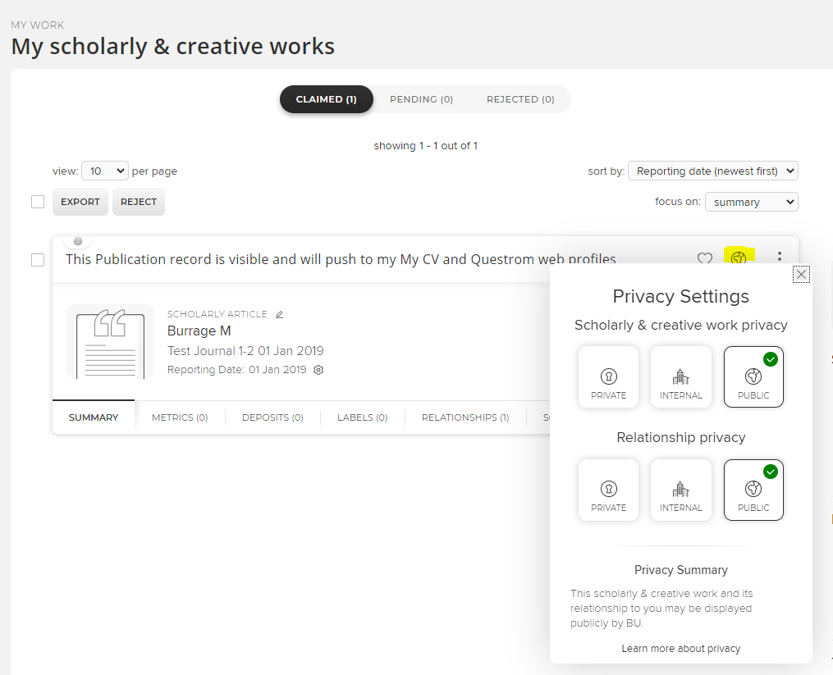

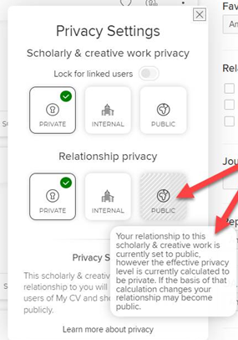
Note: check to make sure that the “Public” option under Relationship privacy does not remain grayed out after you’ve selected “Internal” or “Private.” If it does, click on “Internal” or “Private” again under Relationship privacy to ensure that the item does not remain publicly visible.

