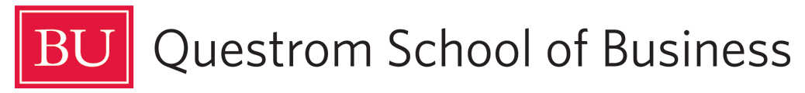

Questrom ITS Accessibility

Introductory Note
Accessibility guidelines help ensure that students with disabilities have equal access to course materials, which is an important aspect of inclusive education. Adherence to accessibility standards can make a significant difference in the ability of students with disabilities to participate fully in their classes and understand course content. By providing materials in a format compatible with assistive technology and following best practices for design and delivery, instructors can help remove barriers that might otherwise prevent students with disabilities from fully engaging with course content. This not only benefits individual students, but also creates a more inclusive learning environment for all students, which can enhance the overall learning experience for everyone in the class.

How Accessibility Scoring Works
Questrom Blackboard has integrated with Ally to create an accessibility scoring system for content uploaded to Blackboard. “Accessibility scores are determined by the severity of issues in each file. A low score indicates the file has severe or multiple accessibility issues; a high score means there are minor or no accessibility issues. For accessibility scores less than 100 percent, Ally gives you suggestions for improving the accessibility of the file.”

Score Icons
Our goal is to have uploaded content score at high or perfect
Low (0-33%): Needs help! There are severe accessibility issues.
Medium (34-66%): A little better. The file is somewhat accessible and needs improvement.
High (67-99%): Almost there. The file is accessible, but more improvements are possible.
Perfect (100%): Perfect! Ally didn't identify any accessibility issues, but further improvements may still be possible.

Best Practices When Creating Class Material
- Use the Microsoft Office suite
- Use the Questrom ITS accessibility-optimized template
- Follow the accessibility checklist
- Use Microsoft Accessibility Checker before sharing
- If sharing as PDFs, use the Adobe Action Wizard tool before sharing

Accessibility Checklist
- All visuals have alt text
- Content on slides can be read in the order you intend
- Color is not the only means to convey any information
- Text and background color have enough contrast
- Every slide has a unique title
- Videos have subtitles/closed captions
- Used Microsoft Accessibility Checker
- Used Adobe Action Wizard Tool for PDFs

Using the Microsoft Accessibility Checker
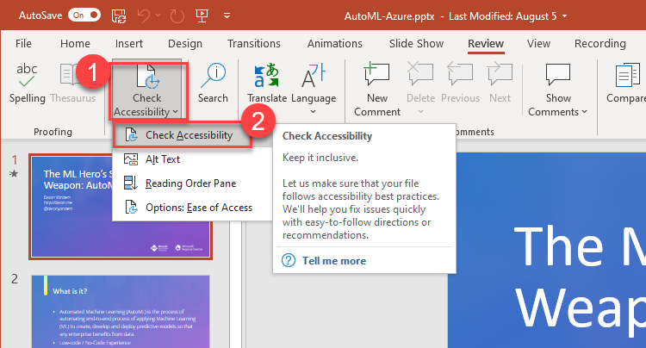
In any Microsoft Application:
- Go to the “Review” tab
- Click “Check Accessibility”
- Follow the directions provided
- For further guidance:
  - For PowerPoint click here
  - For Word click here
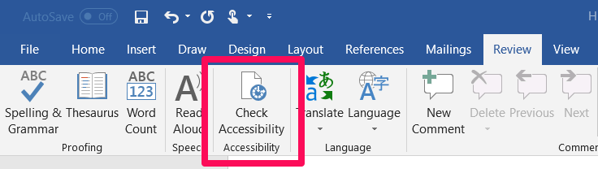
  - For Excel click here

Using the Adobe Action Wizard Tool in Adobe Acrobat
- Chose Tools > Action Wizard
- From the Actions List, click Make Accessible
- Select the files that you want to apply the Make Accessible action to. By default, the action runs on the document that's currently open. Select Add Files to select additional files or a folder to run the action on
- Click Start
- Follow guidelines on Adobe’s support site here
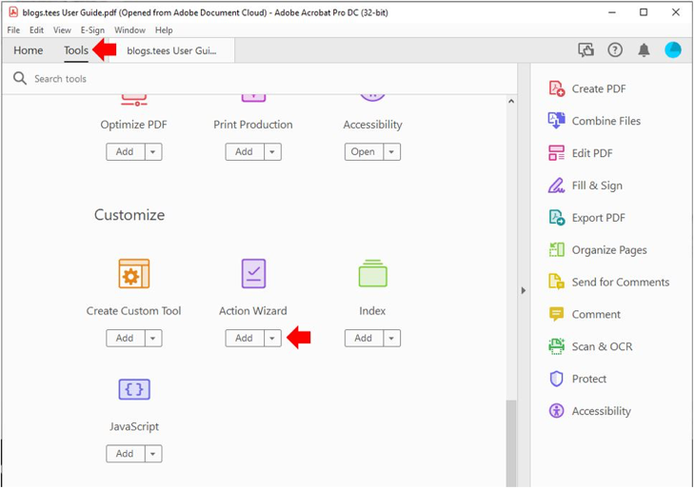
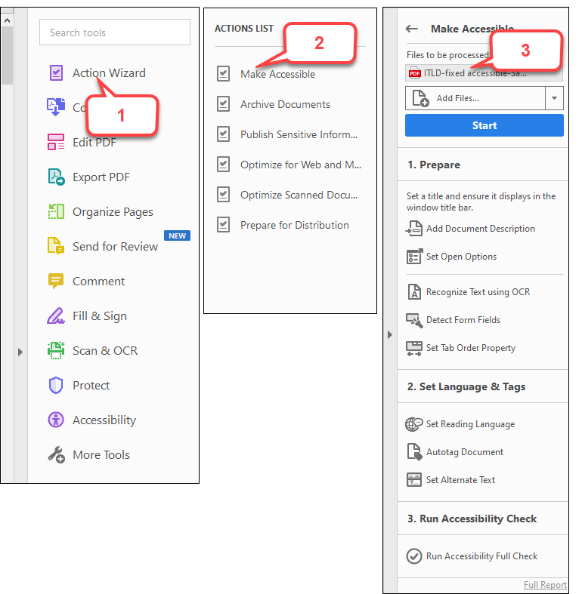

Optimizing for Blackboard
- Documents:
  - Word documents are preferred
  - Keep as DOCX file
- Presentations:
  - PowerPoint presentations are preferred
  - Keep as PPTX file
- Webpages:
  - Use links and hyperlink them to the original page
  - If pages are behind a paywall:
    - Print (Control + P (Windows) OR Command + P (MacOS)
    - Save as PDF
    - Use Adobe Action Wizard
    - Upload PDF to Blackboard

