What is it? PathSource is an app that connects the dots between education, careers, lifestyle and budget. Exclusive informational interviews with professionals give you unbiased insights into thousands of careers! (iOS App: Search “PathSource” in the Apple App Store or follow this link. For website activation use code BOS860)
What are the features?
- Access to over 3,000 informational interview videos
- An interactive budget builder that lets you know your minimum salary needs are for your individual lifestyle
- 60-question self-assessment tool to help point you in the right direction
- Allows you to set up a free account with your BU email
How do I use the app?

Select your category Analyze your budget Watch videos!
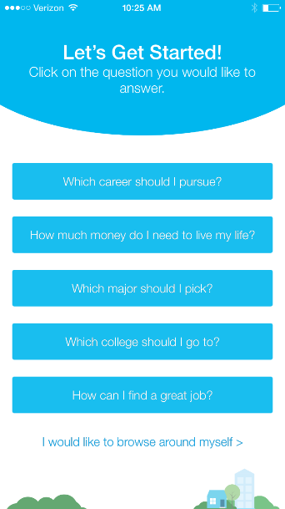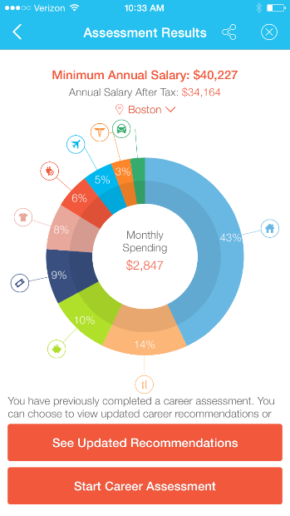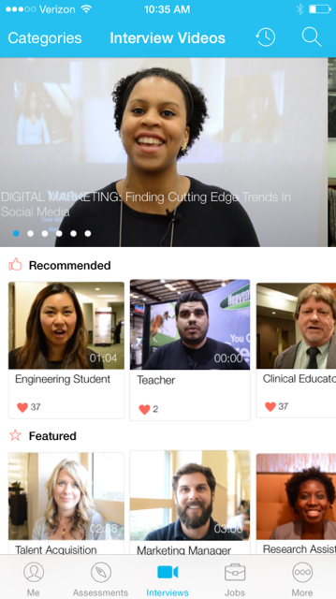

Once you have selected a video, you can learn more about that career path:

Career Details Growth and Salary Local Data
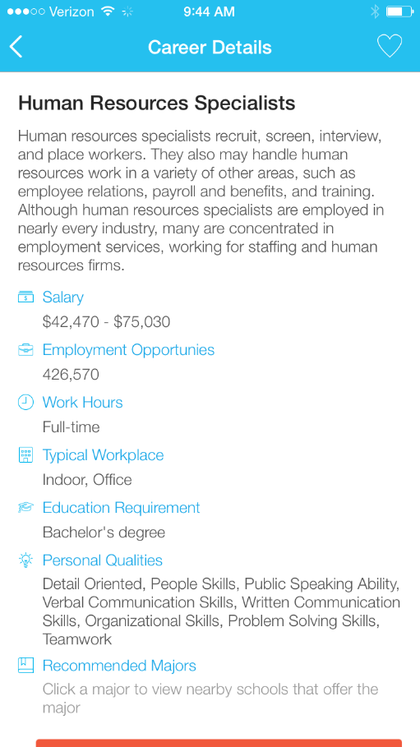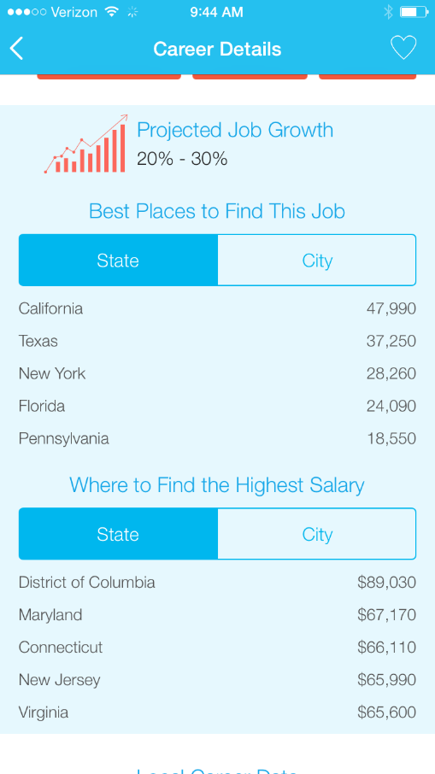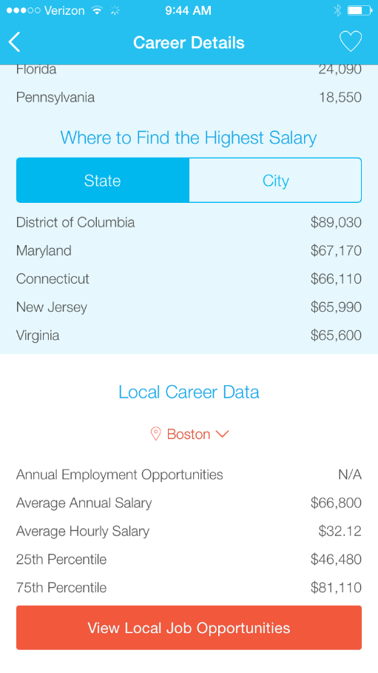

How do I use the website?
The website has similar features, just looks a little different. Remember, the first time activation code is BOS860
If you’re accessing this site from your computer:
- Step 1-Register
- Step 2-Recieve your email confirmation and click the link to activate your account
- Step 3- Log on and enjoy the site!
Explore videos Learn about opportunities
